Name: ___________________________ Date: _________ Block: ___

# Grade 7 Unit 1 Summative 1 REVIEW: The Number System

ADDING AND SUBTRACTING INTEGERS

**Adding:**

**Same Sign**- Add and keep sign

**Different Sign**- Subtract & give sign of number further from 0.

Ex: -5 + 9 = 9 – 5 = 4 (9 was the greater value and positive so answer is positive)

**Subtracting: KEEP, CHANGE, CHANGE**

1. **K**eep the first number
2. **C**hange subtract sign to add
3. **C**hange the sign of the second number
4. Follow adding rules

Ex: -7 – (-4) = -7 + (+4) = 7 – 4 =3 then -3 because 7 was the bigger value and negative

Part A: Perform the indicated operation. Show all work.

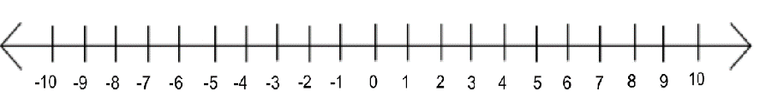1. Use the number line to evaluate 5 + -9.

2. Use the number line to evaluate .



3. A climber scales down a cliff 27 meters. Then goes an additional 16 meters down. How far does the climber have to travel to get back to the surface?

4. Is the equation -7 – (-6) = 7 + 6 true? Explain your answer using words, symbols, or both.

OPERATIONS WITH DECIMALS

1. Use the integers’ rules above to determine which operation to perform.
2. Line up decimals and place zeros in any empty places.
3. Add or subtract like normal. (Do not forget to put the decimal in your answer.)
4. Remember the negative sign if it is needed!

Part B: Perform the indicated operation. Show all work.

5.  = 6. -5.6 – (-7.89) =

7. I owed a friend $15.75. I asked if I could borrow another $7.56 for lunch. How much do I owe my friend?

OPERATIONS WITH FRACTIONS

1. Use the integers rules above to determine which operation to perform.
2. Make equivalent fractions using a common denominator.
3. Add or subtract the numerator and keep the denominator.
4. Simplify if needed.
5. Remember the negative sign if it is needed!

Part C: Perform the indicated operation. Show all work.

8.  = 9. 3 1 - 5 1 =

8 3

10. Janet climbed 1 of a kilometer up a mountain face. It was mid-afternoon so she decided to turn back. She currently has climbed back down  of a mile. How far is she from the bottom? Explain your answer using words, symbols, or both.

Part D: Identify all of the equivalent expressions.

11. 

a.  c. 

b.  d. 

Part E: Fractions to Decimals

Divide the numerator by the denominator. This means that the numerator is on the inside of the division bar and the denominator is on the outside of the division bar.

12. Convert each fraction to a decimal and identify either terminating or repeating.

a. 7 =

8 _______________ Terminating Repeating

b. 3 =

9 _______________ Terminating Repeating

13. Malby had a small chocolate bar that was 5 ¾ ft. long. He had eaten 2.97 ft. of the chocolate bar. How many more feet does he have left to eat? Show your work.

14. Solve. Show your work.

7 3 – 4.35 =

5